**EXPERIMENT 2**

Name : Urvashi Rathore

SAP ID : 500083262

**AIM: Working with Docker (Basic Commands)**

Steps to Complete:

1. Search a Redis image on DockerHub

**command : docker search redis**

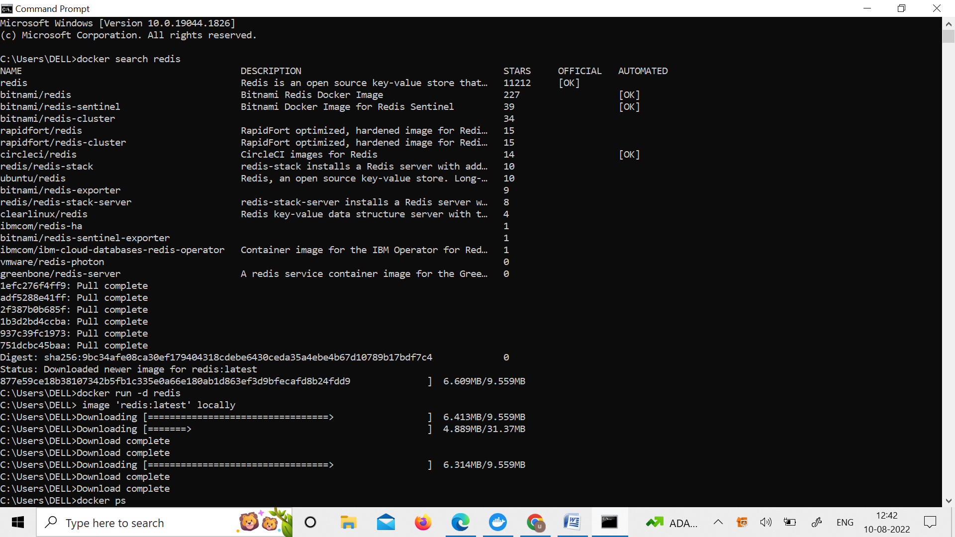

1. 2. Run Docker Container of Redis Image in background

**Command** : docker run –d redis

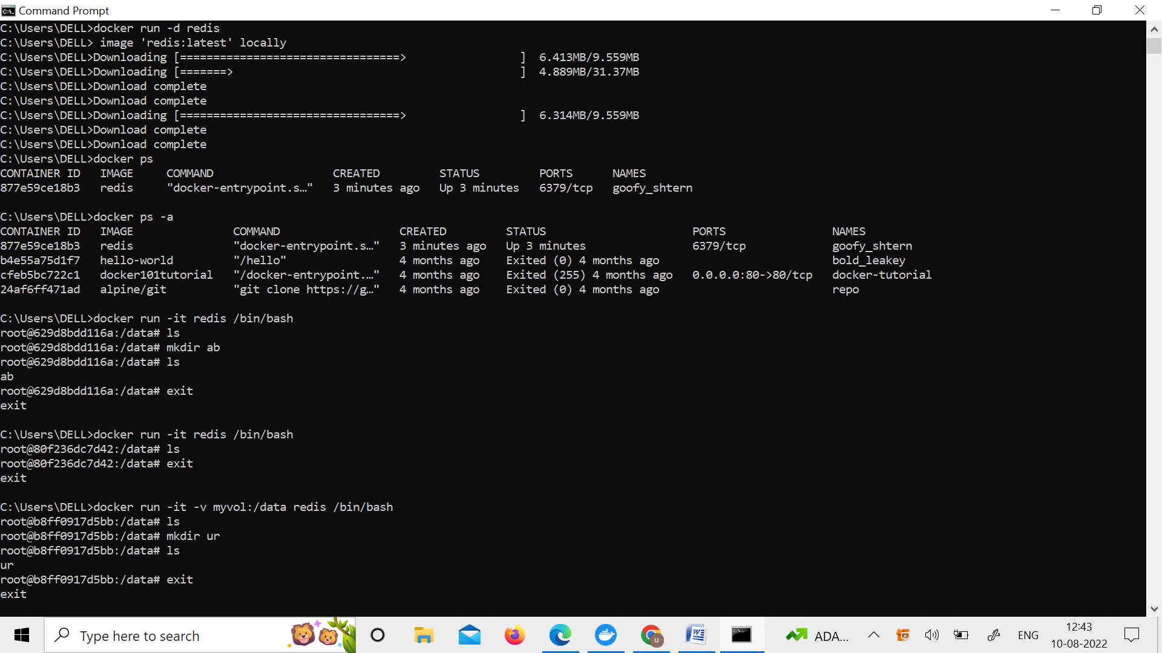

1. Run Docker PS and Docker PS –a

**command : docker ps**

**docker ps -a**



1. Run Docker Container and take its console

**Command : docker run –it redish /bin/bash**

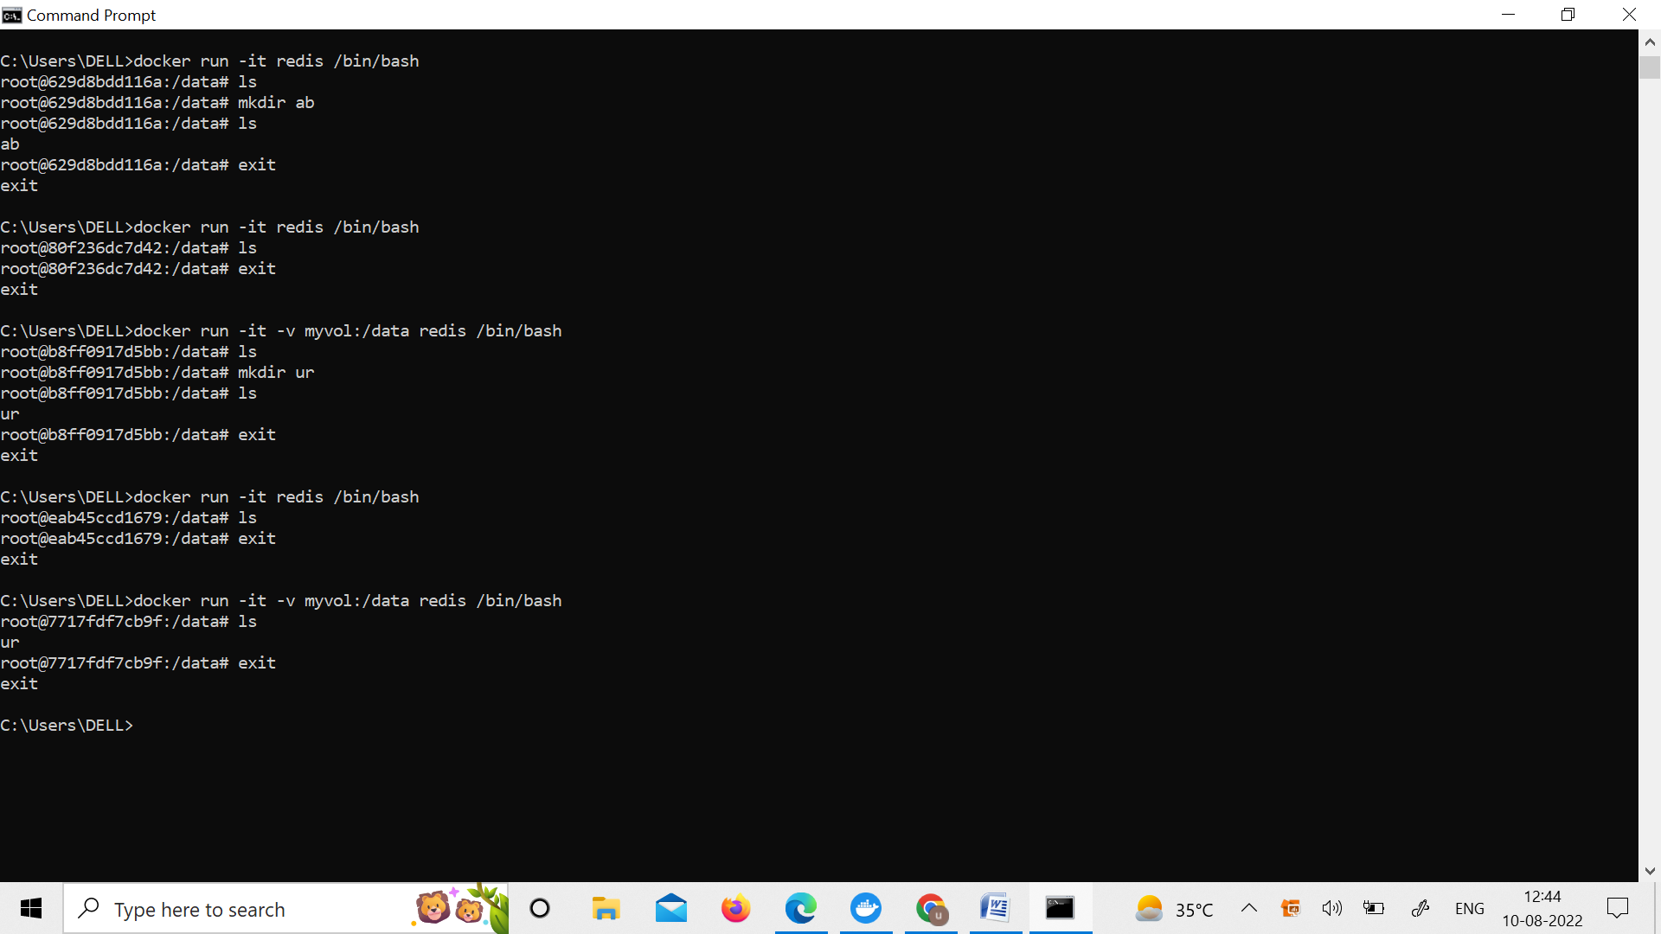

1. Create a Docker Volume and connect it

**Command : docker run –it –v nyvol:/data redis /bin/bash**

